Calor Gas Recommended Retail Price

Prices including 5% VAT

Butane Small – Cylinder Sizes : Cube, 4.5 kg Butane, 7 kg Butane - £49.00
Propane Small – Cylinder Sizes : 3.9 kg Propane, 6 kg Lite, 6 kg Propane - £49.00

Butane Medium – Cylinder Sizes : 12 kg Butane, 15 kg Butane - £49.99

Patio Small – Cylinder Size : 5 kg Patio - £49.99

Patio Large – Cylinder Size : 13 kg Patio - £54.99

Propane Large – Cylinder Size : 12 kg FLT Propane, 18 kg FLT Propane, 19 kg Propane & 47 kg Propane - £69.99

Bettyhill Garage Prices

Prices including 5% VAT. Delivery, exchange and fitting to the campsite free of charge

4.5 kg Butane - £22.00
7 kg Butane - £33.00
15 kg Butane - £54.00

3.9 kg Propane - £21.00
6 kg Propane - £30.00
13 kg Propane - £50.00
19 kg Propane - £51.00
47 kg Propane - £114.00

13 kg Patio Gas - £52.00
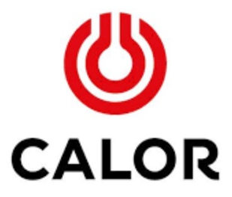 Tel : 01641 521801 to order a replacement

